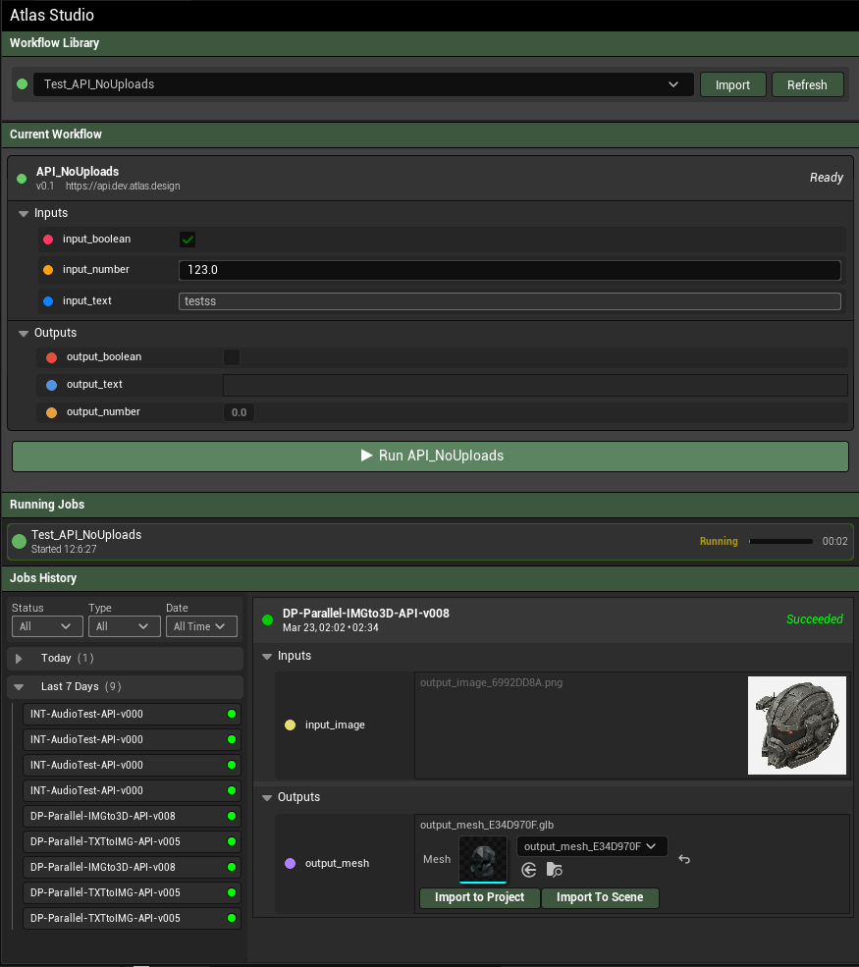

Individual Elements

Main Header

Section Header

Workflow Selection Panel
- Status Circle
- Dropdown with previously loaded workflows
- Imnport button
- Refresh Button

Selected Workflow Panel

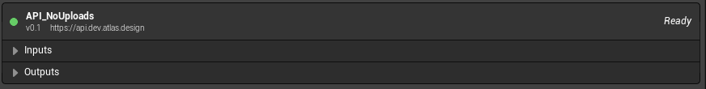
- Header with status Circle, Name, version, and url
- Collapsible section for Inputs
- Collapsible section for outputs

Input Parameter Row
- One for each parameter type ( string, bool, number, image, mesh)
- Has 2 modalities
  - As input: is enabled and allows configuring
  - As output: is disabled/grayed out
- Bool type has a checkbox
- Number type has a number spinner
- String type has a edit field
- Image type has ability to select from project or from file system
- Mesh type is same as image type

Run Workflow Button

Running Job Card
- Status circle
- Workflow Name
- Started time
- Continuous progress bar
- Elapsed time

Job History Selector
- Allows for browsing of previously run and stored jobs
- Has a filtering feature by status, workflow type and date
- Also has a list view separated by 3 categories ( today, yesterday, last week, older)
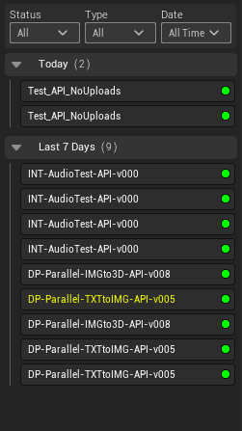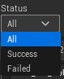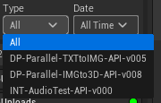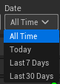

Job results Panel
- Similar to the current workflow
- Contains a header with:
  - Circle status
  - Workflow name
  - Generation Time
  - Generation duration
  - Status Label
  - Input parameters collapsable
  - Output parameters collapsable
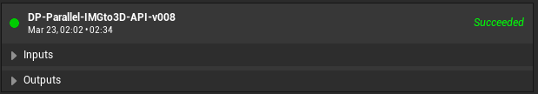

Completed Job parameter row
- Similar to the parameter row but for finished jobs
- The input parameters show the values that were used such as what string, number, image, etc. They cant be edited
- The output parameters show the results and allow for different things according to the value type
  - Text ones allows to copy text but not modify it
  - Images and mesh ones allow for importing into the project or showing where file were imported to
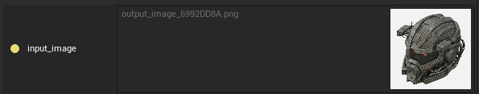
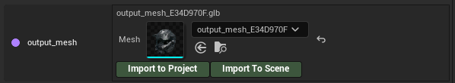
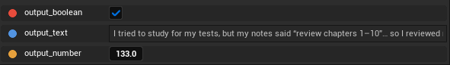

Sections
Sections are composed by individual Elements

Workflow Library
- Section Header
- Workflow Selection Panel
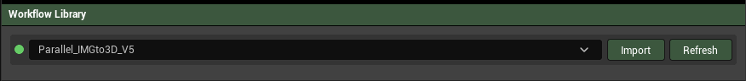

Current Workflow
- Section Header
- Selected Workflow Panel
  - Input Parameter rows dynamically created for the input and output collapsibles
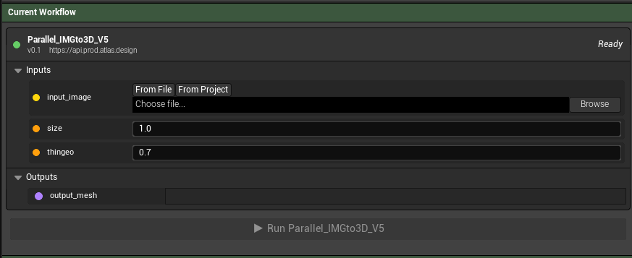

Running Jobs
- Section Header
- Dynamically generated Running Job Cards
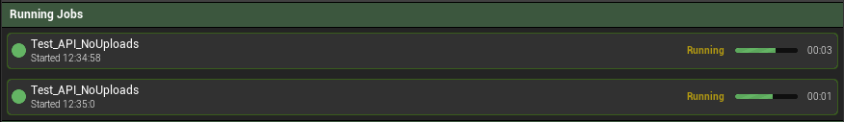

Job History
- Section Header
- Horizontal split
  - Job history Selector on the left
  - Job Results Panel on the right
    - Dynamically generated Completed Job parameters in the input and output collapsibles
